**LMS ATOMICS DESIGN**

1. **ATOMS**

* Buttons



This is because looking at the website this are the two button formats being used

* Text

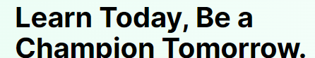

* Icons

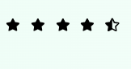 

* Input

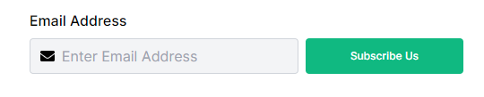

**B Molecules**

* Form

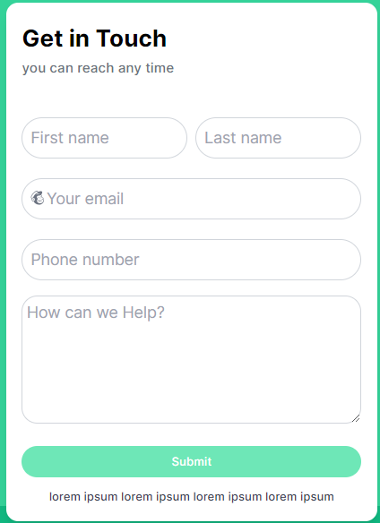 

* Card

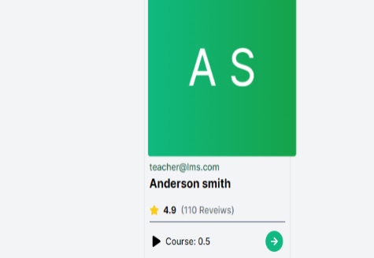

* Sidebars

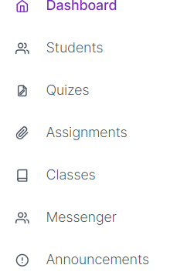

1. **Organism**

* Courses.jsx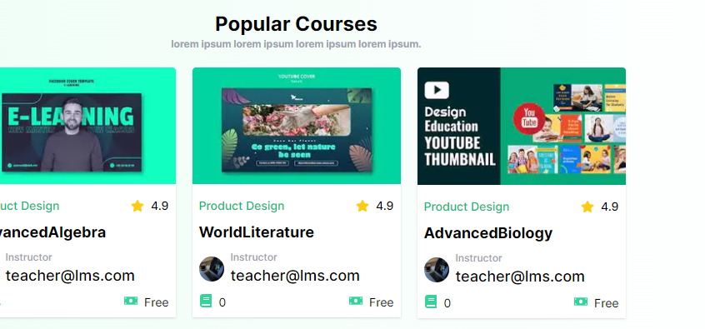
* Header.jsx



* Footer.jsx

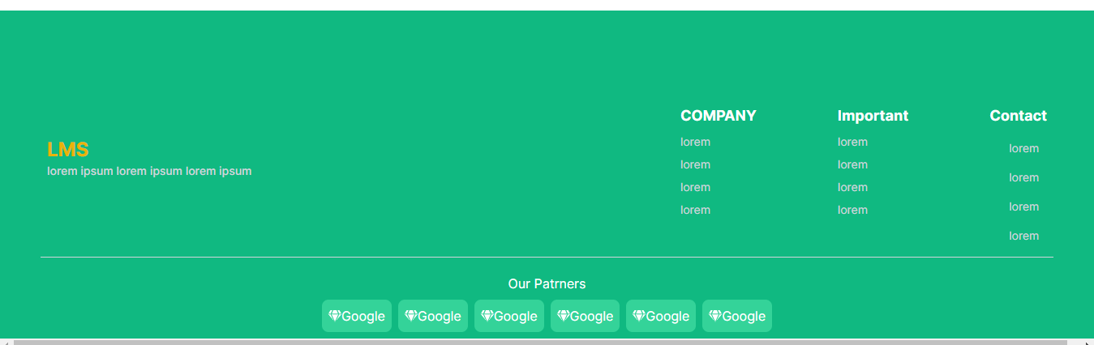

* **Student/Teacher Dashboard**

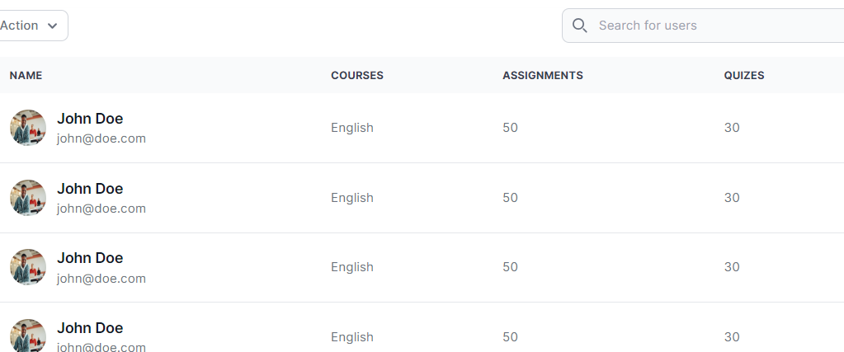

**Quiz Dashboard**

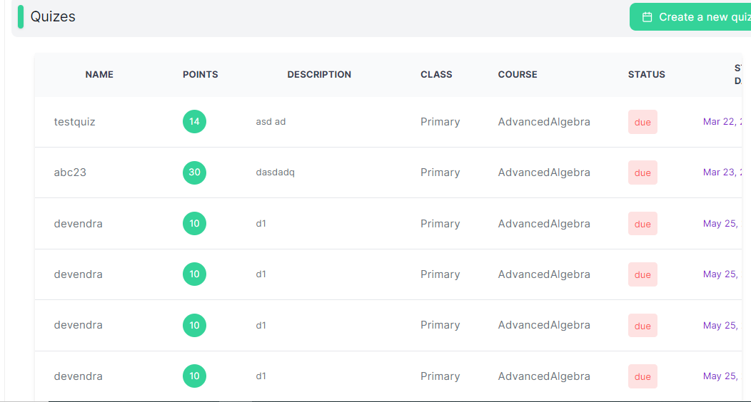

**D)Templates**

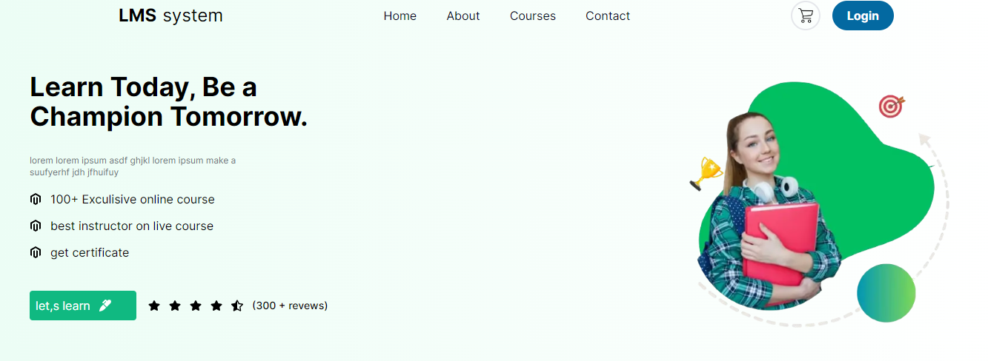

**E)Pages**

* Homepage

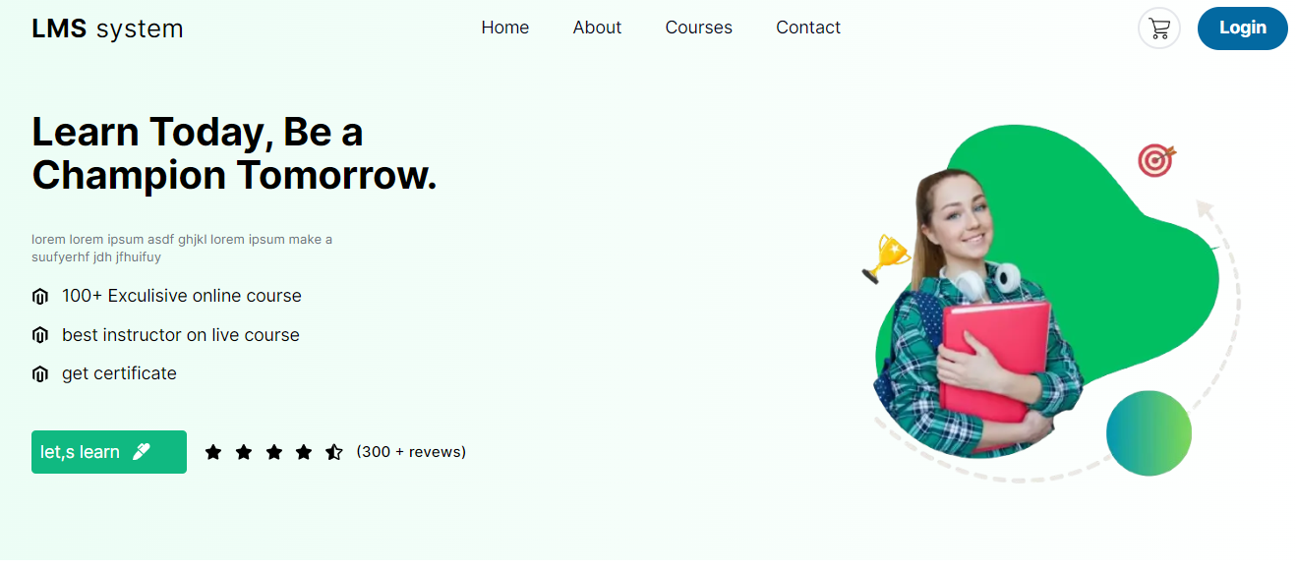

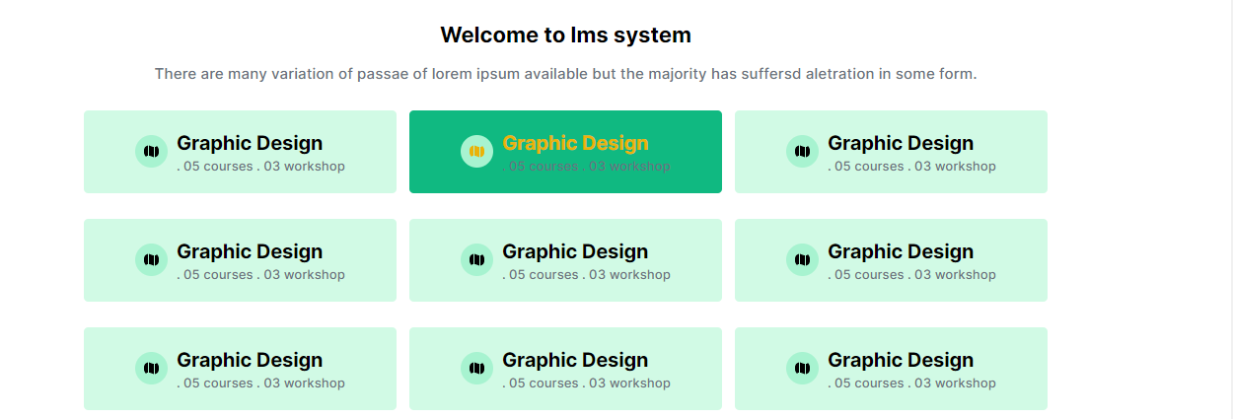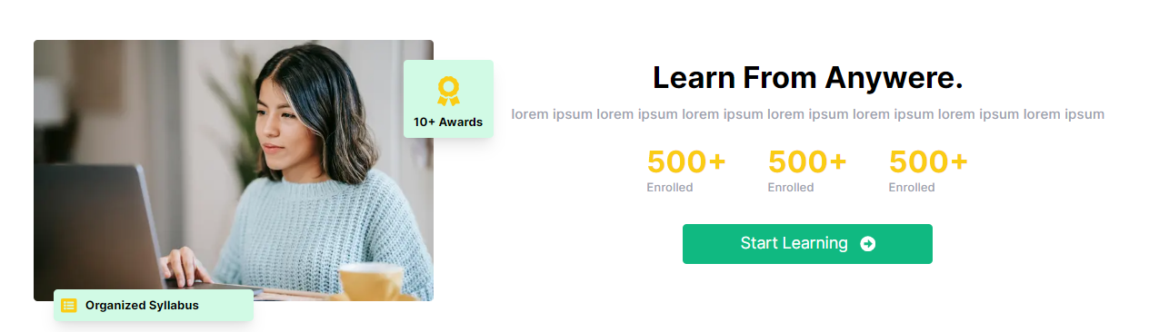

* Courses page

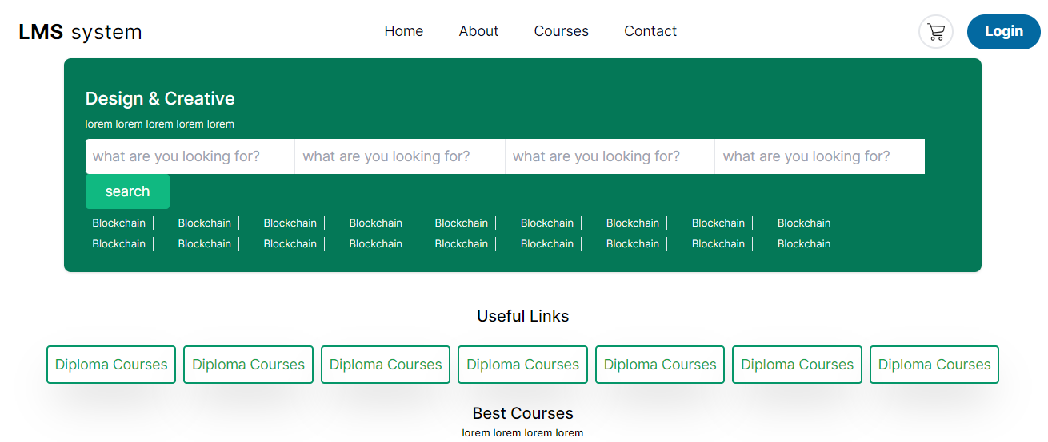

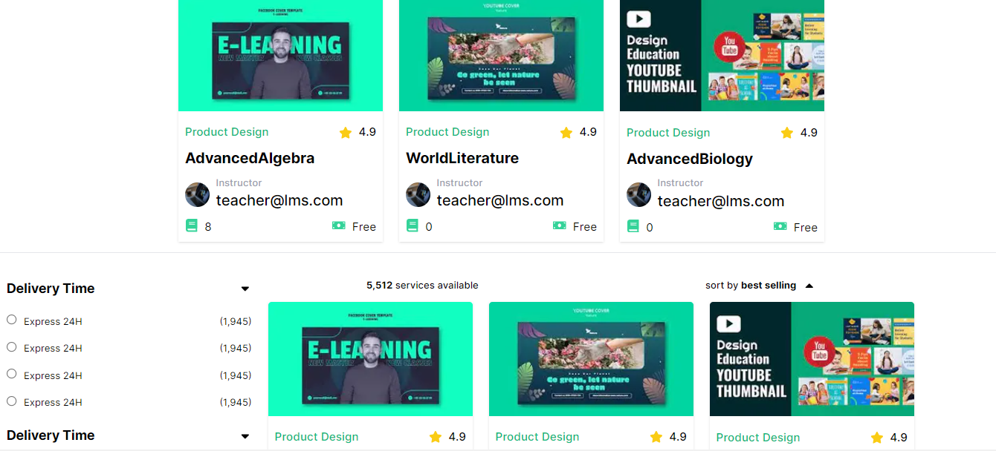

Contact page

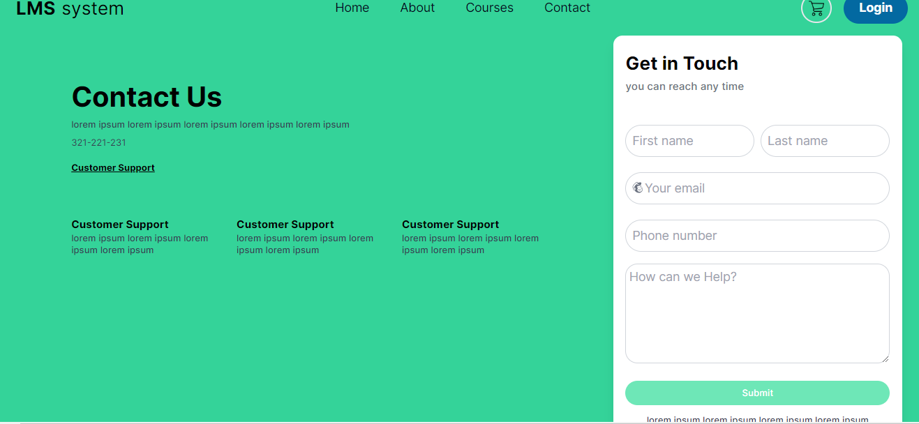

* Login page

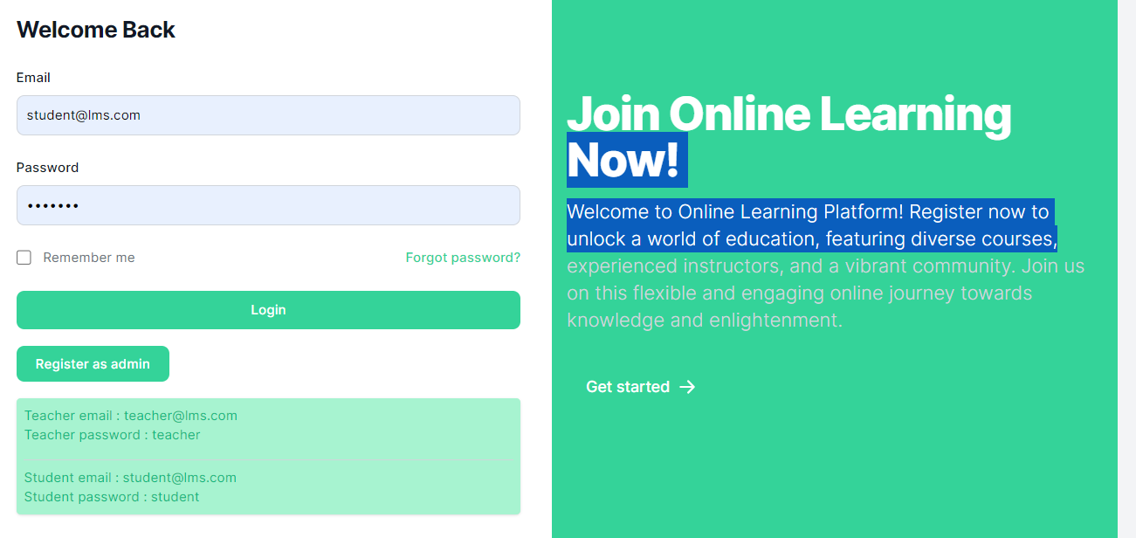

Subpages under the login page

**A) Admin dashbord**

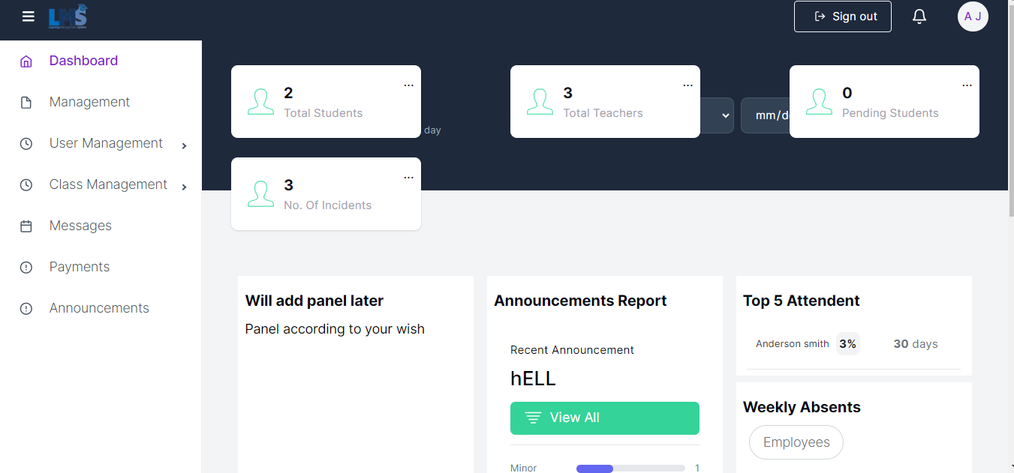

**B)Teacher Dashboard**

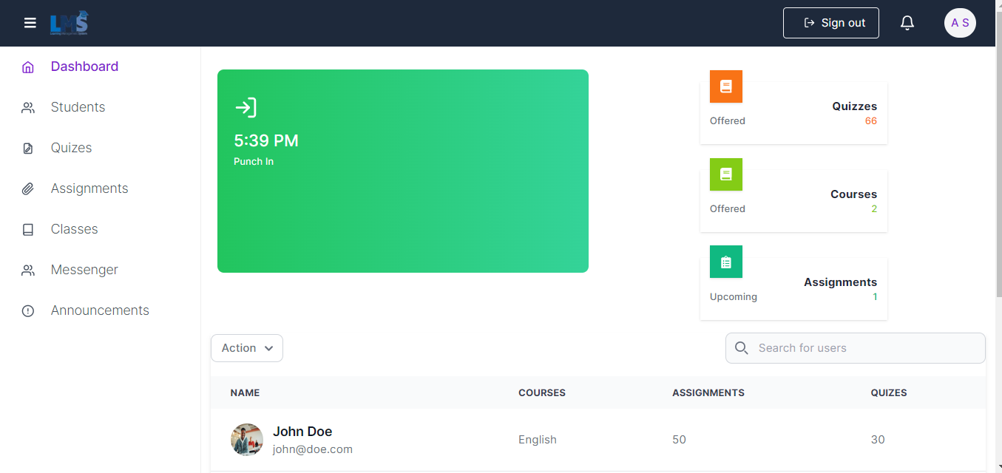

**Subpages under teacher dashboard**

1. **Assignment page**

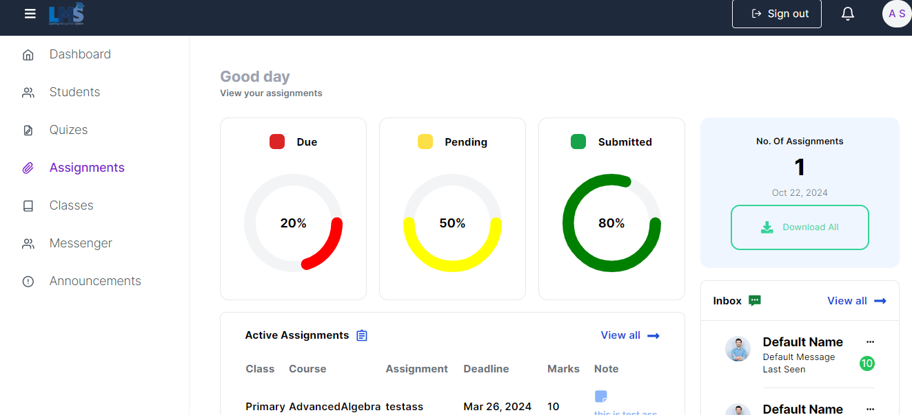

**II) Quizz page**

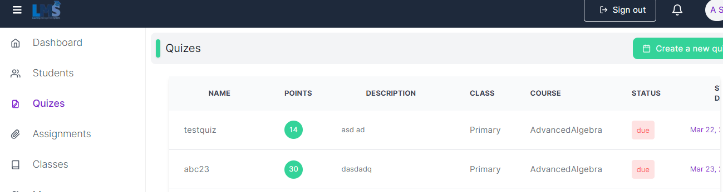

**III) a student page where the teacher can view the number of students enrolled**

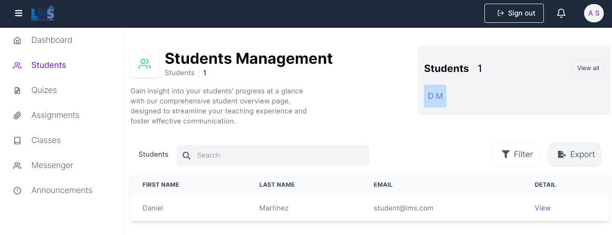

**C)Student dashboard**

